|  |  |  |  |  |  |
| --- | --- | --- | --- | --- | --- |
| Date | 6-Dec-22 | | | Tester Name | Mohammad Yusuf |
| Environment | Penfax - Test | | | Login used |  |
| Operating System | Windows | Version: | Update: | | |
| Software Used | Select Software | Version: | Update: | | |
| Select Software | Version: | Update: | | |
| Release version |  | | | | |
| Title |  | | | | |
| Test Type | Regression | | | | |
| Test Scenario |  | | | | |
|  |  | | | | |
| Expected Results |  | | | | |
| Pass/Fail | Select | | | JIRA# | N/A |

Describe your steps with screenshots:

Pre-condition: Login into the application.

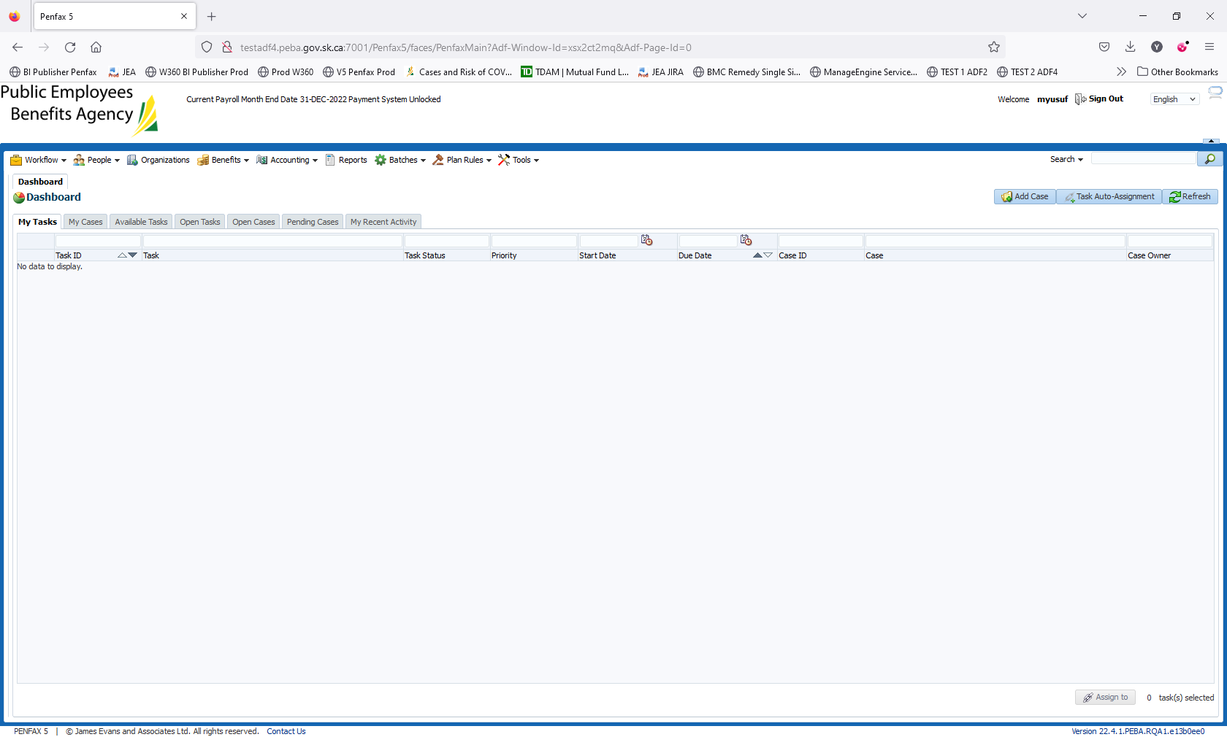

Click on Reports on top bar

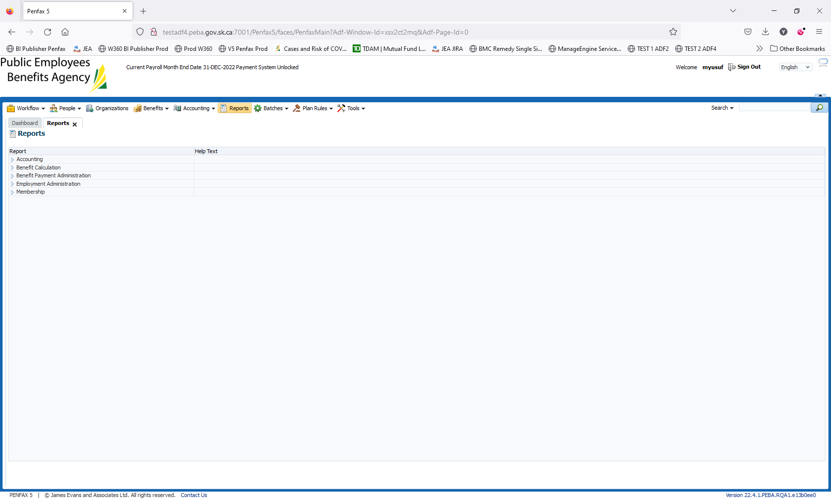

Expand the Employment Administration

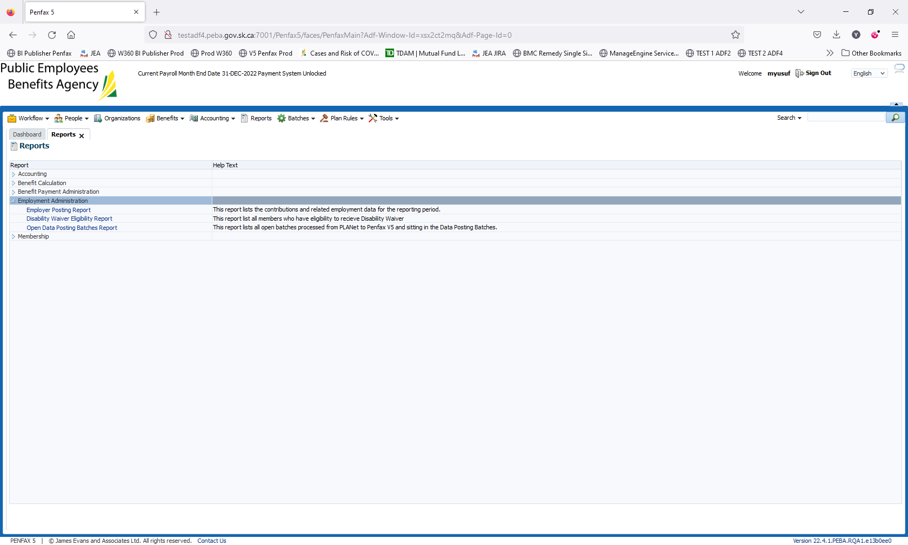

Click on the report – Open Data Posting Batches Report

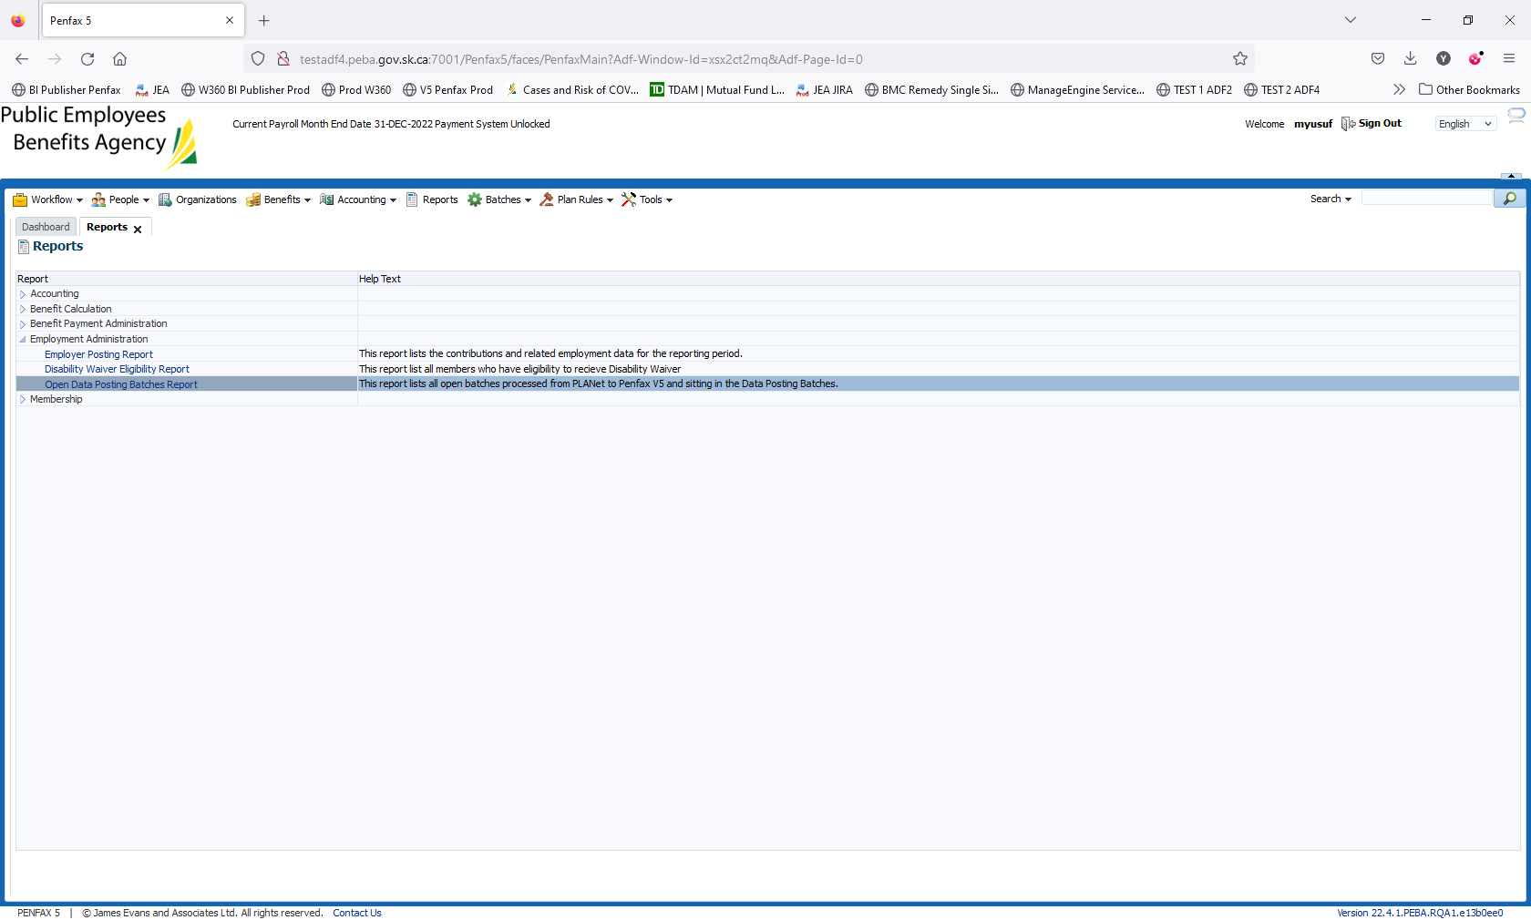

After clicking on the report. It should start getting downloaded

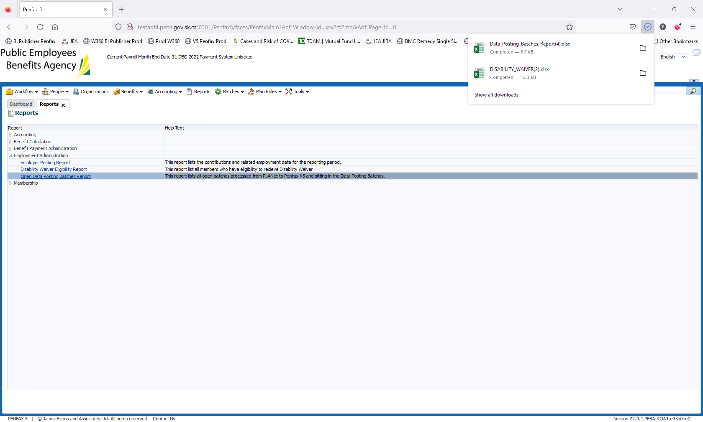

Click on the Data_Posting_Batches_Report. Report should open in Excel.

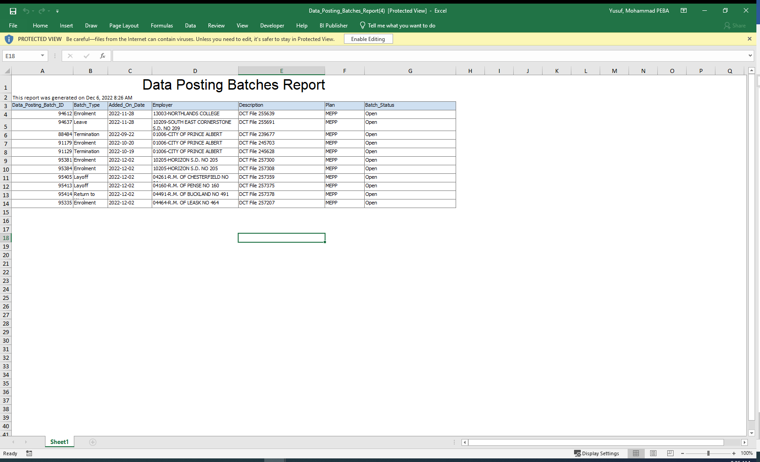

To Validate the data from Penfax.

Navigate to Batches -> Data Posting Batches

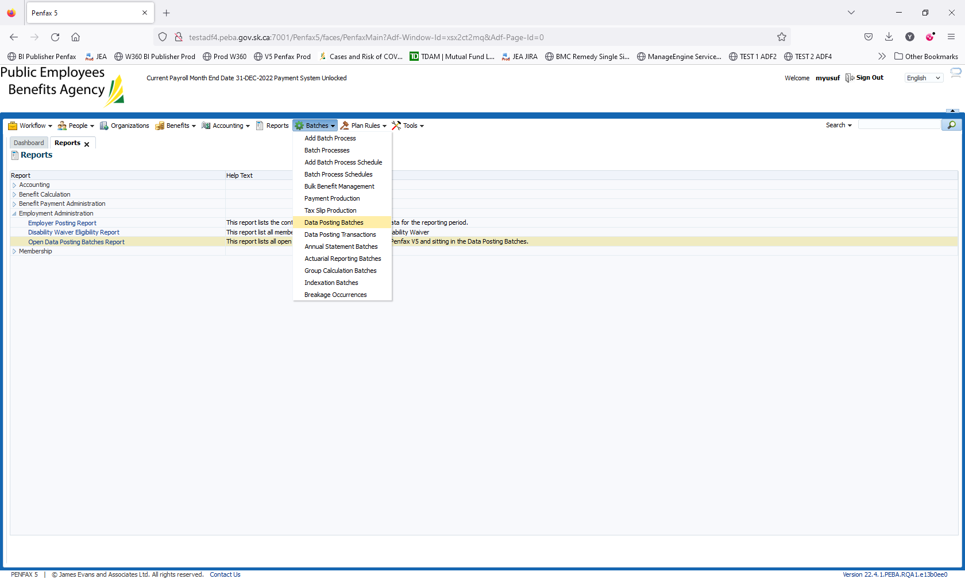

Enter the following parameters in the Search

Plan: MEPP

Batch Status: Open

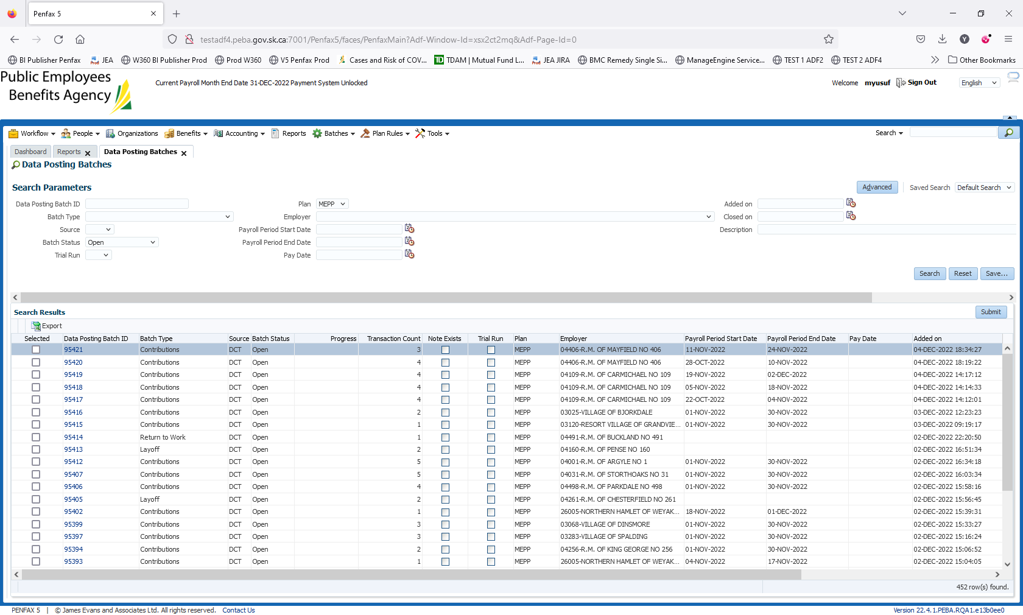

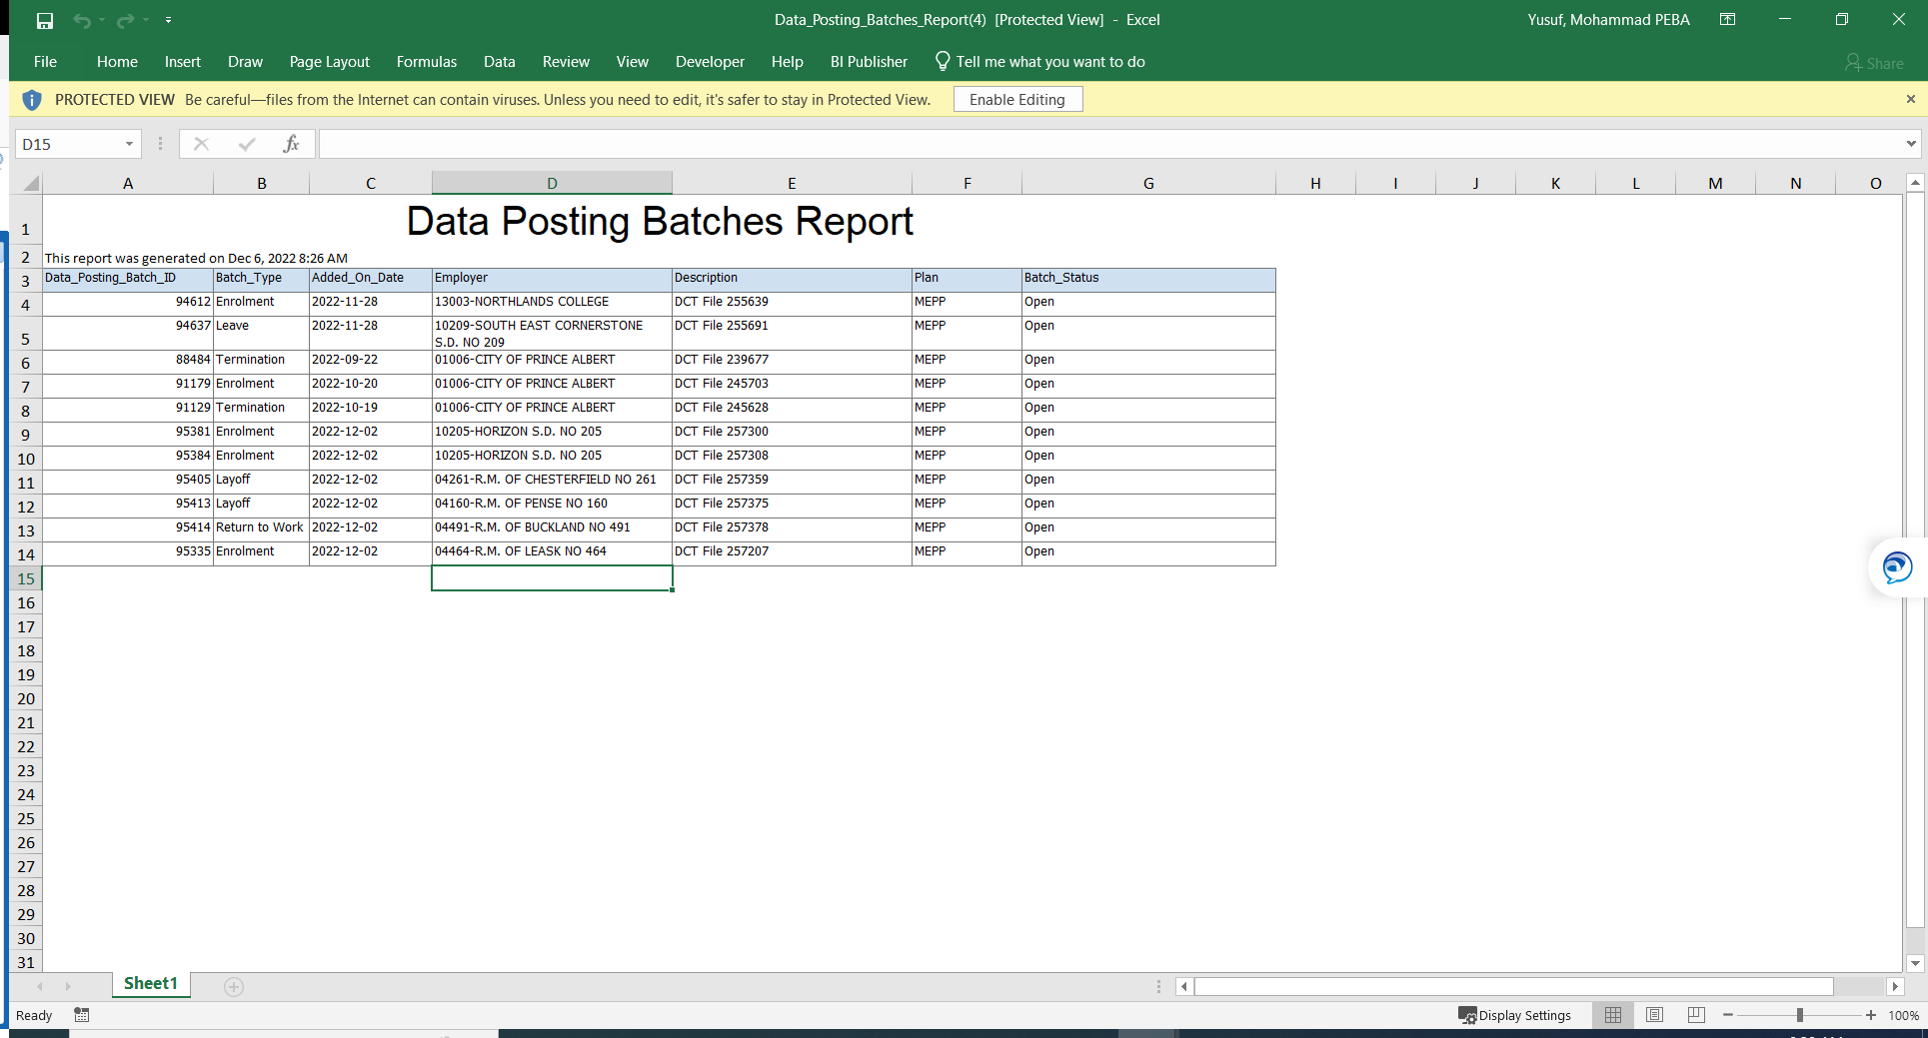

Note: Validated this info. With Rosie

This report only captures the forms. So this report should capture all the following Open forms

Enrollment

Leave

Termination

RTW

Layoff

Address Change

It should not capture Contribution open batches.

Validated the data with Penfax. All 5 enrollment batches are open. Result is passed

